SQL Server - Migration of WSUS Windows Internal Database (SQL Express) from WID to SQL Server Procedure (Generic)
Actions
Migrating the WSUS database
- Stop the IIS and WSUS services on the WSUS server
- Open PowerShell (elevated), Run as Administrator
- Then Execute the following Script:
Stop-Service IISADMIN
Stop-Service WsusService
- Detaching SUSDB from the Windows Internal Database
- Open SQL Management Studio (Run as Administrator)
- Connect to the Database using Connection String "\.\pipe\MICROSOFT##WID\tsql\query(Double slash in the beginning)
- Right-click SUSDB -> Tasks -> click Detach.
- Below screenshot of SQL Server Management Studio showing the SUSDB > Tasks > Detach option selected.
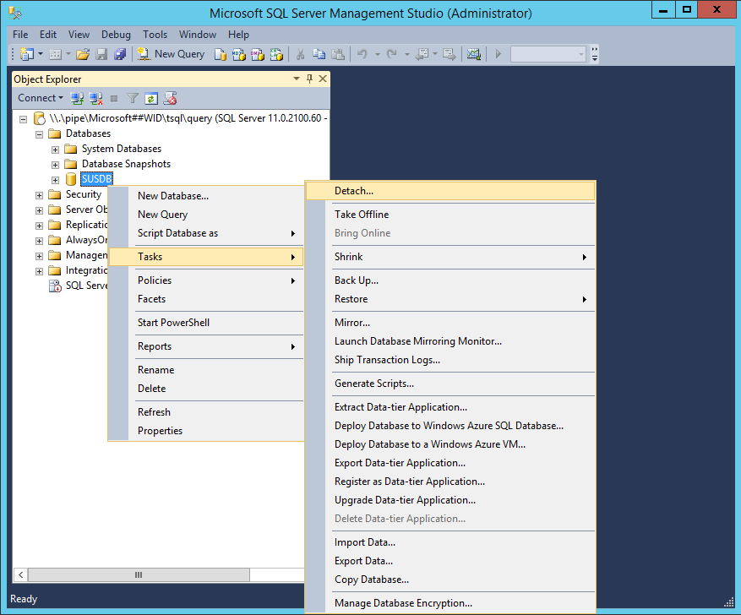
- Check Drop Existing Connections and click OK (optional, if active connections exist).
- Below screenshot of the Detach Database dialog box with the Drop Existing Connections option selected and the OK option highlighted.
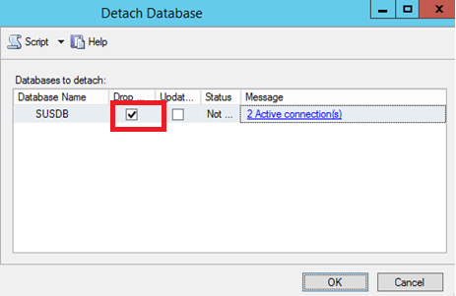

Detach DB using Command Prompt
- Open an elevated command prompt
- Run the following SQL command to detach the WSUS database (SUSDB) from the Windows Internal Database instance by using the sql cmd utility:
sqlcmd -S \\.\pipe\Microsoft##WID\tsql\query
use master
GO
alter database SUSDB set single_user with rollback immediate
GO
sp_detach_db SUSDB
GO

Copy the SUSDB files to the SQL Server
- Copy SUSDB.mdf and SUSDB_log.ldf from the WID Data Folder (%SystemDrive%\Windows\WID\Data) to the SQL Instance Data Folder.
Note: SQL Instance Folder is C:\Program Files\Microsoft SQL Server\MSSQL12.MSSQLSERVER\MSSQL, and the WID Data folder is C:\Windows\WID\Data, copy the SUSDB files from C:\Windows\WID\Data to C:\Program Files\Microsoft SQL Server\MSSQL12.MSSQLSERVER\MSSQL\Data

Attach SUSDB to the SQL Instance
- In SQL Server Management Studio, under the Instance node, right-click Databases, and then click Attach.
- Below screenshot of SQL Server Management Studio showing the Databases > Attach option selected.
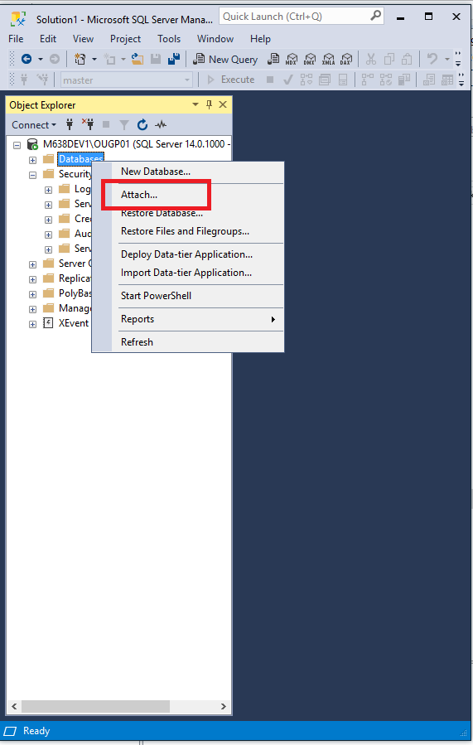
- In the Attach Databases box, under Databases to attach, click the Add button and locate the SUSDB.mdf file (copied from the WID Folder), and then click OK.
- Below screenshot of the Attach Databases dialog box with the Add option highlighted. Screenshot of the Locate Database Files dialog box with the SUSDB.mdf file highlighted.
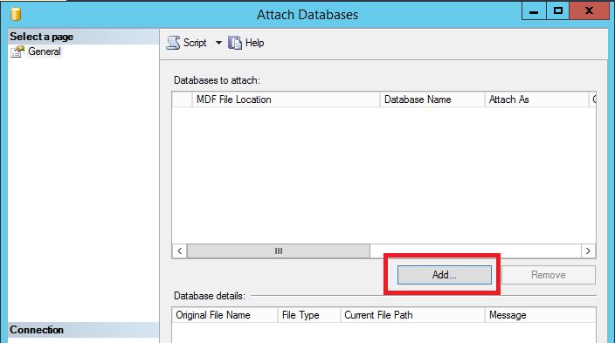
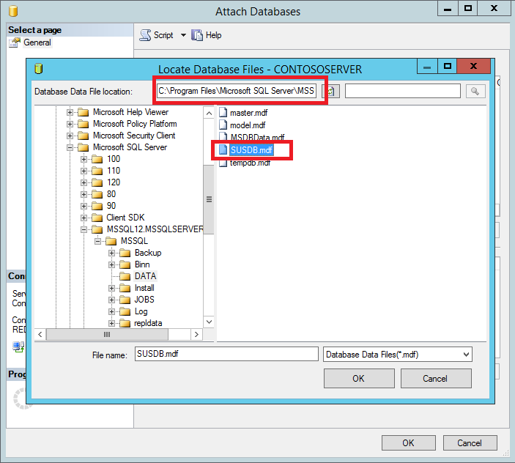

Attaching SUSDB using script
USE master;
GO
CREATE DATABASE SUSDB
ON
(FILENAME = 'C:\Program Files\Microsoft SQL Server\MSSQL12.MSSQLSERVER\MSSQL\Data\SUSDB.mdf'),
(FILENAME = 'C:\Program Files\Microsoft SQL Server\MSSQL12.MSSQLSERVER\MSSQL\Log\SUSDB_Log.ldf')
FOR ATTACH;
GO

Verify SQL Server and Database Logins and Permissions
- After attaching the SUSDB, verify that NT AUTHORITY\NETWORK SERVICE has login permissions to the instance of SQL Server by doing the following:
  - Go into SQL Server Management Studio
  - Opening the Instance
  - Click Security
  - Click Logins
  - The NT AUTHORITY\NETWORK SERVICE account should be listed. If it is not, you need to add it by adding New Login Name.
Note: If the SQL Instance is on a different machine from WSUS, the WSUS Server's computer account should be listed in the format <ComputerName>\<WSUS Administrators>. If not, the steps below can be used to add it, replacing NT AUTHORITY\NETWORK SERVICE with the WSUS Server's computer account (<ComputerName>\<WSUS Administrators>) This would be in addition to granting rights to NT AUTHORITY\NETWORK SERVICE.

Adding NT AUTHORITY\NETWORK SERVICE and granting it rights
- Right Click Logins and click New Login…
- Below screenshot of SQL Server Management Studio showing the Logins > New Login option selected.
- On the General page, fill out the Login name (NT AUTHORITY\NETWORK SERVICE), and set the Default database to SUSDB.
- Below screenshot of the General page of the Login dialog box showing the Login name and Default database fields populated.
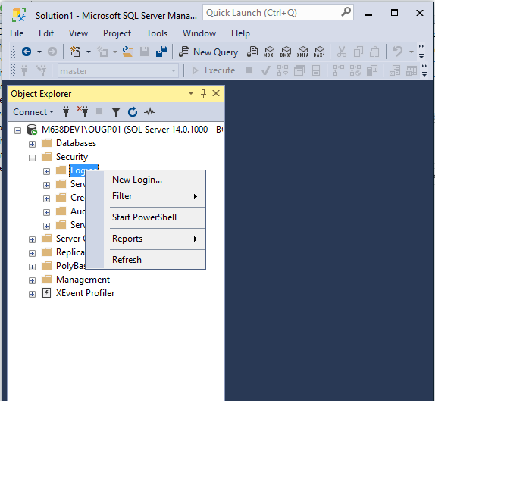

- On the Server Roles page, ensure public and sysadmin are selected.
- Below screenshot of the Server Roles page of the Login dialog box showing the public and sysadmin options selected.
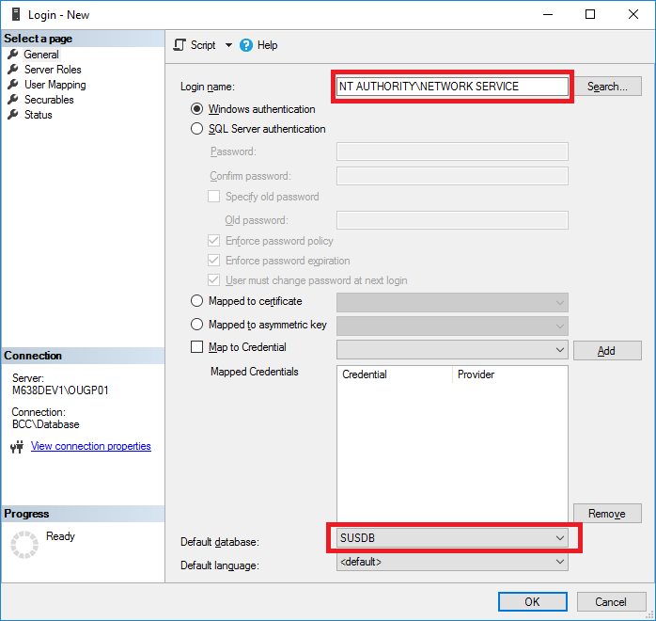

- On the User Mapping page:
- Under Users mapped to this login: select SUSDB
- Under Database role membership for: SUSDB, ensure the following are checked:
  - public
  - web Service
- Below screenshot of the User Mapping page of the Login dialog box showing the public and web Service options selected for the account.
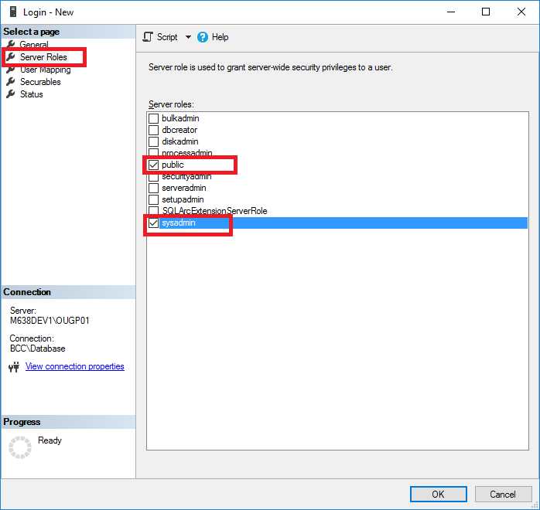
- Then Click OK
- You should now see NT AUTHORITY\NETWORK SERVICE under Logins.
- Below screenshot of the Object Explorer showing NT AUTHORITY NETWORK SERVICE under Logins.
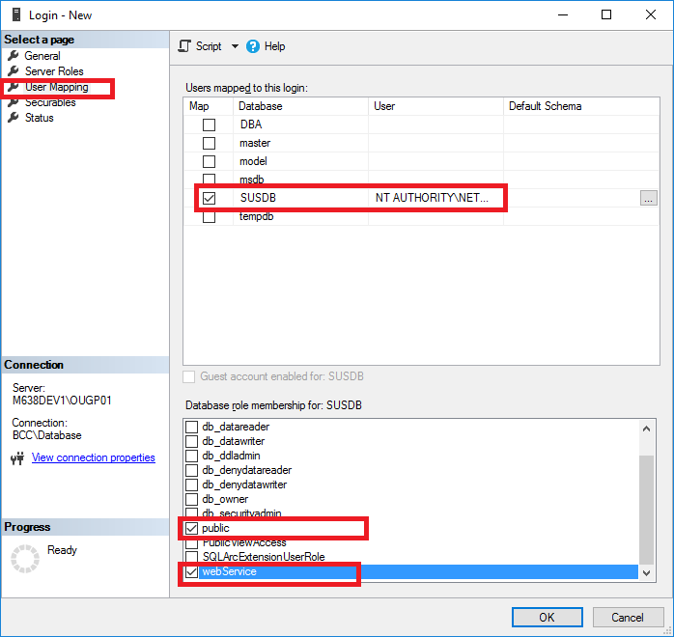

Database Permissions
- Right-click the SUSDB
- Select Properties
- Click Permissions
- The NT AUTHORITY\NETWORK SERVICE account should be listed.
- If it is not, add the account
- Verify that the Default database is set to SUSDB.
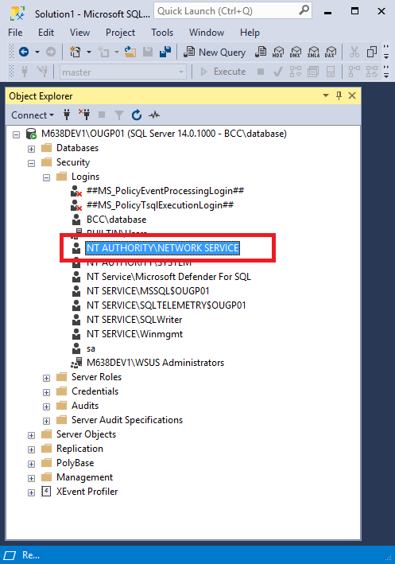

Adding <ComputerName>\WSUS Administrators and granting it rights
- Right Click Logins and click New Login.
- On the General page, fill out the Login name (<ComputerName>\WSUS Administrators), and set the Default database to SUSDB.
- On the User Mapping page:
- Under Users mapped to this login: select SUSDB
- Under Database role membership for: SUSDB, ensure the following are checked:
  - public
  - web Service
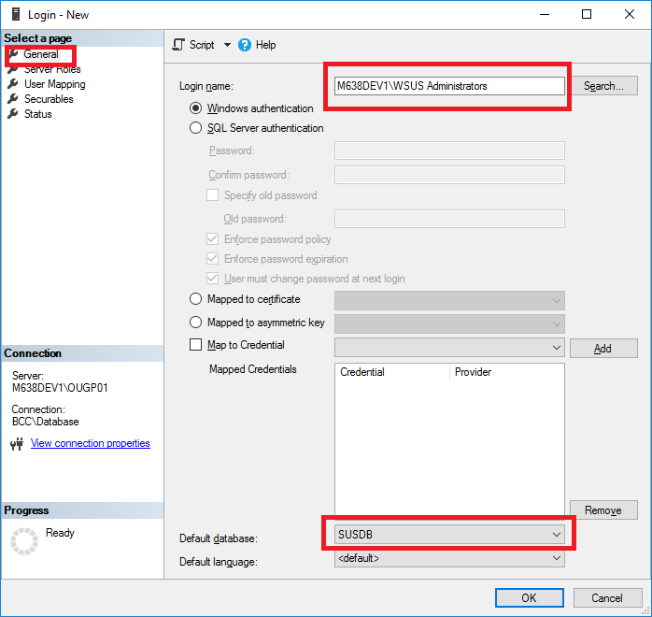
- On the Server Roles page, ensure public and sysadmin are selected.
- Below screenshot of the Server Roles page of the Login dialog box showing the public and sysadmin options selected.
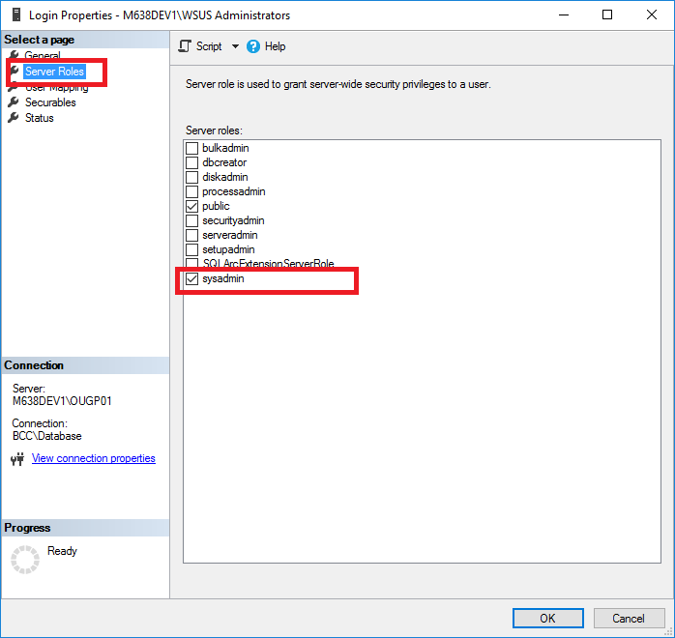
Note: You may need to restart the SQL Service for the changes to take effect.

Edit the registry to point WSUS to the SQL Server Instance
Note: Follow the steps in this section carefully. Serious problems might occur if you modify the registry incorrectly. Before you modify it, back up the registry for restoration in case problems occur.
- Click Start, click Run, type regedit, and then click OK.
- Locate the following key: HKEY_LOCAL_MACHINE\SOFTWARE\Microsoft\UpdateServices\Server\Setup\SqlServerName
- In the Value text box, type <ServerName>\<InstanceName>, and then click OK. If the instance name is the default instance, then type <ServerName>.
- Locate the following key: HKEY_LOCAL_MACHINE\SOFTWARE\Microsoft\Update Services\Server\Setup\Installed Role Services\UpdateServices-WidDatabase
- Below screenshot of the Registry Editor dialog box with the UpdateServices-WidDatabase key highlighted.
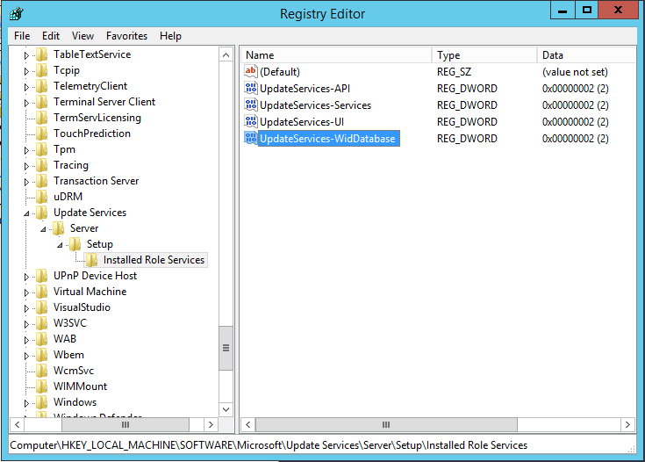
- Rename the Key to UpdateServices-Database
- Below screenshot of the Registry Editor dialog box showing the key name update to UpdateServices-Database.
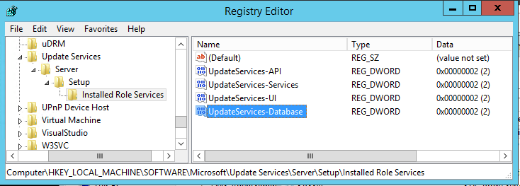
Note: If you do not update this key, then WsusUtil will attempt to service the WID rather than the SQL Instance to which you have migrated.

Start the IIS and WSUS services on the WSUS server
- Open PowerShell (elevated) with run as administrator, and run the following command
Start-Service IISADMIN
Start-Service WsusService
Note: If you are using the WSUS Console, close and restart it.

Uninstalling the WID role (not recommended)
Removing the WID role also removes a database folder (%SystemDrive%\Program Files\Update Services\Database) that contains scripts required by WSUSUtil.exe for post-installation tasks. If you choose to uninstall the WID role, make sure you back up the %SystemDrive%\Program Files\Update Services\Database folder beforehand.

Uninstalling the WID role using PowerShell:
Uninstall-WindowsFeature -Name 'Windows-Internal-Database'
- After the WID role is removed, verify that the following registry key is present: HKEY_LOCAL_MACHINE\SOFTWARE\Microsoft\Update Services\Server\Setup\Installed Role Services\UpdateServices-Database

